Alabama Library Association
6080 Monticello Dr
Montgomery, AL 36117
(334) 414-0113 | http://allanet.org

FY2013 ALABAMA LIBRARY DISASTER ASSISTANCE
GRANT APPLICATION

Grants are $250 each.

DUE: April 1, 2013

A. Applicant Information

Library Name:_______________________________________________________________________

Address:___________________________________________________________________________

___________________________________________________________________________________

Contact Person:_____________________________________________________________________

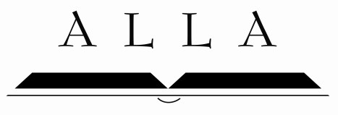
Phone No:_________________________________ Fax No:__________________________________

Email for Contact Person:____________________________________________________________

Check Mailing Address (if different from Library’s address):

____________________________________________________________________________________

B: Description of Damage Received

Using the space below, please provide a brief description of the damage sustained and the area(s) affected; attach photos if possible.

C. Plans for Grant Funds

Every library that receives the Alabama Library Disaster Assistance Grant is required to provide the following basic library services.

  - Provide a collection of books and other materials for loan
  - Provide access to interlibrary loan (ILL) services
  - Provide reference services
  - Provide reading and/or educational programs for children

Briefly describe your plans for these funds, if received. Use a separate sheet of paper if necessary.

Library Director/Dean/Principal:

Print or Type Name:___________________________________________________________

Signature:___________________________________________________________________

Title______________________________Date______________________________________

Questions? Contact Angie More, 334-414-0113/allibraryassoc@gmail.com.

Copy application for your files and return original application to:
Grants Administrator,
Alabama Library Association, 6080 Monticello Dr.,
Montgomery, AL 36117

OFFICE USE ONLY:
Date Received_________________________
Received by___________________________

